1. control the robot using joint angles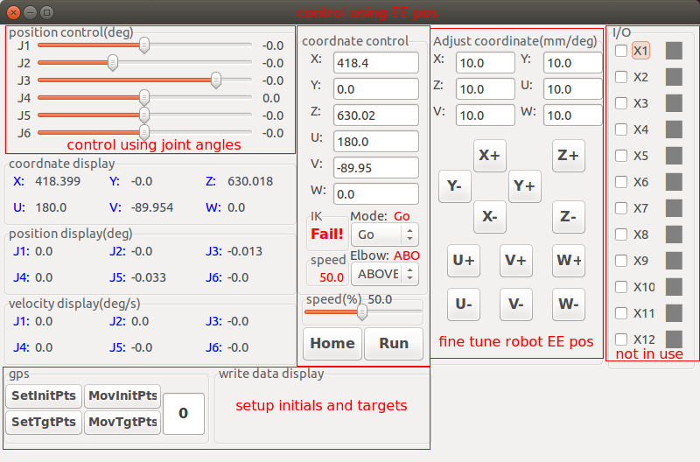

Just use the bars at upper-left corner

2. control the robot using end-effector positions

a) type in the desired coordinates

b) we strongly recommend to choose MODE: GO and Elbow: ABOVE but you can play with other options to see the difference

c) speed controls how fast the robot moves, not important

d) click “Run”, if IK displays “Fail!”, it means the coordinate cannot be reached

e) “Home” button resets the robot to initial position

3. fine tuning

a) adjust the step size

b) press the corresponding buttons

4. setting up initials and targets for GPS

a) adjust the number in the box, the number represents condition number

b) move the robot to desired position

c) press “SetInitPts” or “SetTgtPts” to save initials or targets to the corresponding condition

d) press “MovInitPts” or “MovTgtPts” to move to the saved initials or targets